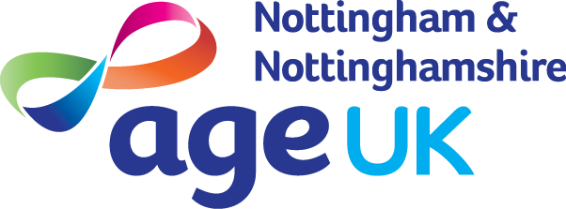
Age UK Notts supports older people (over 50yrs) within the City & County.

Below are five FREE services to help clients save money & stay safe:
- Benefits check T: 0115 8599 209
A short assessment can find out if a client is entitled to any benefits and help them to apply.
- Home Energy Checks T: 0115 8599 260
Free supply and fitting of energy saving measures, e.g. draught excluders, energy saving light bulbs, etc

- Heating & Housing Repairs T: 0115 8599 260
Funding available to help those who may need financial assistance for heating and home repairs.

- Age UK Business Directory T: 0800 0114 643
The Age UK Business Directory provides a way for clients to find trustworthy tradespeople in their area.

- Covid-19 Welfare Service: T: 0115 844 0011
We can help with shopping and prescription delivery during the health crisis.

