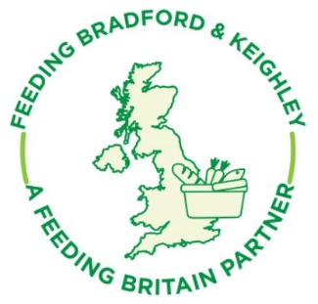
AGENDA - Feeding Bradford & Keighley 18th January 2021

- Who’s here

- Quick Update from the network
  - New website
  - Foodbank support
  - Update on social supermarkets and low cost
  - Healthy Holidays and family crisis support
  - Advice Worker in Feeding Projects
  - Street food and support for homeless and destitute
  - Council Food Strategy

- Focus on food and food waste
  - Best before and use by dates, how to safely look after food at home and for your project and ideas to minimise waste. Natalie from Gateway, Soraya from Cooking at Storehouse and Juli from Inn Churches

- Priorities for 2021 – if time allows if not please email
Life for many of us is pretty busy, though there are lots on-line meetings I am missing the networking opportunities of face to face meetings.
  - Is there any greater co-ordination which you think would really help your work and improve things for the people of Bradford?
  - Or a question you would like to get answered from other projects or service users?
  - Please email ideas to Cathy.henwood@wellspringstogether.org.uk

- Any other issues from the floor

- Date of next network meeting 19th April proposed date

