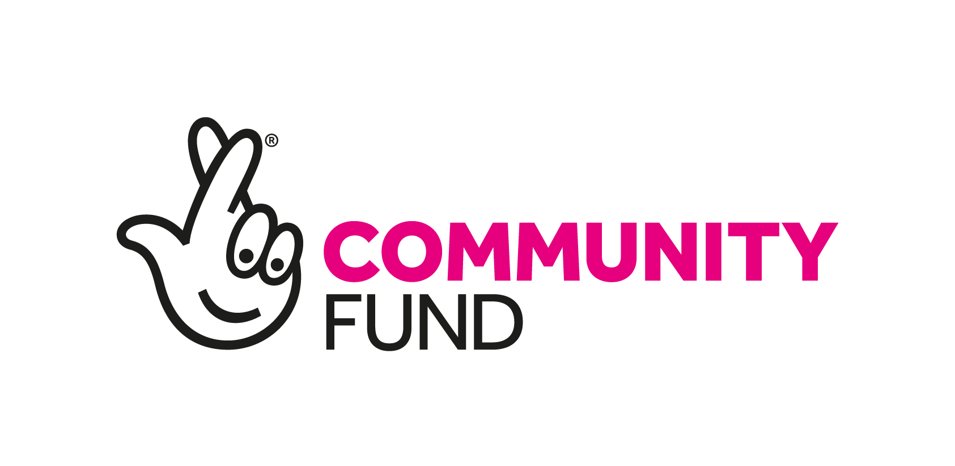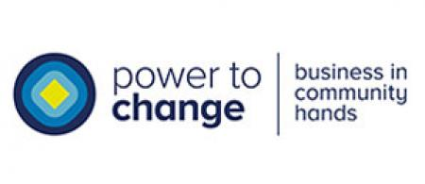
BAME Development Officer
PLEASE NOTE:
- In accordance with the Equality Act 2010, the work constitutes a genuine occupational requirement for the postholder to be of a BAME background.
- This post is funded by the National Lottery. We understand that this may be a concern for some applicants.
Job Description:
Responsible to: Together Middlesbrough & Cleveland Chief Officer and Board of Trustees
Hours: Full time (37.5 hours per week) Secondment and Job Share options welcomed
Location: South Tees - Middlesbrough & Redcar & Cleveland
Key Partners: Include local churches, community centres and schools, Middlesbrough Environment City, Food Partnership and Food Power Alliance members, Local Authorities, MVDA, & RCVDA

Salary: £26,813 pa

Project length: Initially Fixed Term temporary contract to the end of March 2021

Job Purpose:
To develop and co-ordinate TM&C’s BAME Development Work. Using evidence collated from the recent COVID Impact Survey, working with churches, faith groups, community groups, schools, and local agencies, to map existing provision and explore routes to recovery. To promote understanding and awareness of the specific issues facing our BAME residents.

Main Duties:
The post holder will be responsible for the development, co-ordination, and implementation of a programme of BAME development work, based on the ethos and values of TM&C. Key tasks will include: mapping of existing BAME organisations and associated provision in Middlesbrough and Cleveland; working with these organisations, BAME residents, and other key stakeholders, to explore how to effectively co-ordinate the provision, and identify gaps; lead on the Bowes Museum Art and Wellbeing Project; and other potential partnerships with art and cultural organisations.

Also, to develop opportunities to work with TM&C colleagues and partners to ensure existing TM&C projects are accessible and appropriate for our BAME residents; and seek to connect all elements of our community. You will be expected to use mature judgement and initiative in establishing priorities, planning your work, and seeing it through to completion.

Project development
- Asset-map the existing BAME resources, activities, and networks across South Tees
- Seek opportunities to provide co-ordination of existing BAME provision and identify gaps
- Seek opportunities to identify, work with, and involve, local BAME-led businesses in COVID support and recovery solutions
- Work with the Food Insecurity Project Officer to identify potential new BAME-led/focused providers of Feast of Fun holiday hunger provision with the relevant experience and capacity in the priority communities
- Develop a model that can be delivered building on the assets in each local community, and within current COVID-19 guidelines and legislation
- Work with existing and new providers to maximise resources and assets at a local level
- Identify training and development opportunities within existing and new providers and plan appropriate training and development in partnership with other agencies
- Identify examples of good practice and learning to share across holiday provision projects
- Develop a network of partner organisations that will work with local providers to support a range of enrichment activities for the physical, social, emotional, and spiritual development of BAME residents
- Work with local groups, MVDA, RCVDA, Teesside University, and other agencies to grow a network of BAME volunteers
- Lead on the Bowes Museum Art and Wellbeing Project for 60+ years old BAME residents, and other seek to identify potential partnership opportunities with other art and cultural organisations
- Maintain effective lines of communication between key partners and providers
- Manage the project budgets and ensure they are as cost effective as possible
- Maintain accurate records and monitoring information, write and present reports regarding the work undertaken, as required
- Your contract will include a requirement to comply with the reasonable instructions given by or on behalf of the Board of TM&C. It will include a requirement in relation to the management or avoidance of conflicts of interest.

General:
- To work within the values and policies of Together Middlesbrough & Cleveland at all times
- To take part in line management supervision and appraisal as required
- To ensure any information processed for both service users and staff is kept accurate, confidential, secure, and in line with GDPR and Together Middlesbrough & Cleveland’s Confidentiality Policy
- To have a duty and responsibility for personal health and safety and the health and safety of colleagues, service users, and visitors
- To attend meeting, training, and events as required – subject to current social distancing and COVID-19 restrictions
- To undertake other tasks commensurate with the position as required.

Line management and employment matters

The TM&C Chief Officer will be assigned as your line manager.

Your contract will include provision in respect of statutory entitlement to leave, sickness absence, grievance and disciplinary procedure, etc.

Probation and notice period

The appointment is subject to safer recruitment procedures. The usual three-month probationary period is not applicable due to the Fixed Term nature and length of the contract. During the contract, the notice that you are required to give TMC is one month.

Place of work

From 2020, all TM&C posts will be home-based. Hot desk arrangements in partner organisations will be available as required. Flexible working will be necessary, including some weekend and evening work. You will be required to travel independently within the Middlesbrough and Redcar & Cleveland area as part of ordinary working. You may be required to attend a reasonable number of conferences and meetings elsewhere in the country. Reasonable travel expenses necessarily incurred in performing your duties will be reimbursed. All of the above arrangements are subject to, and in accordance with, current social distancing and COVID-19 restrictions in place at the time.

Hours and Remuneration

The working time of the post is 37.5 hours per week, subject to short-term variation by mutual agreement. There is no overtime payment, but time off may be taken in lieu. Leave is based pro-rata on a full-time entitlement of 25 days plus public holidays (10 days over 5 months).

The gross remuneration is £26,813 pa (or £ pro rata if Job Share). After four months’ employment the company makes a pension contribution of up to 7.5% of gross salary to the employee’s chosen pension scheme.

Person specification
This document sets out the skills and experience required for this post and will be used for shortlisting and interviewing candidates.
Requirements | Essential | Desirable
Education/Qualifications
- Degree level education in a relevant subject, or substantial evidence of relevant experience that has demonstrated ability.
- Be able to clearly demonstrate a good level of critical thinking and written communication skills.
Experience
- At least three years relevant work experience
- Experience of working with the public in a community development role.
- Experience of project development, planning and management.
- Experience of co-designing projects with beneficiaries.
- Experience of partnership working with organisations and professionals including statutory and voluntary, community or faith-based groups.
Knowledge
- Knowledge and understanding of asset-based community development.
- Knowledge of the challenges faced by low -income families.
- Knowledge of the impact of ‘Holiday Hunger’ on children and young people.
- Local geographic knowledge of Middlesbrough and Redcar & Cleveland and the different local communities.

Skills  - Excellent verbal communication skills, able to establish and maintain effective relationships with a diverse range of people.  - Excellent written communication skills, and computer skills, including use of Excel, Word, Powerpoint and social media.  - Excellent organisational skills.  - Ability to empower and work with people in local communities, harnessing their skills and experiences.  - Ability to network and develop effective partnerships.  - Ability to think reflectively and respond appropriately to challenges.  - Ability to work as part of a team towards a common objective.  - Ability to manage and support volunteers. | All essential
Personal  - As above, in accordance with the Equality Act 2010, it is a genuine occupational requirement for the postholder to be from a BAME background  - Smart appearance and a warm and friendly personality.  - A commitment to the values and aims of TM&C.  - Compassionate, person centred and non-judgmental approach.  - Self-motivated and able to work on their own initiative.  - Someone who expects and works to high standards.  - Willingness to work within TMC’s policies and procedures.  - Willingness to undertake professional development.  - Ability and willingness to work flexibly.  - Ability to travel independently using your own transport. | All essential  A

