King’s Lynn Church Activities

Beacon Church
Rev Jonathan Price
https://www.facebook.com/BeaconChurch.NorthLynn/
St Edmundsbury Road, PE30 2DR
The church will be opening in August.
Coffee on the Couch Thursday 10:00 – 11:30 Highgate Chapel
Community Meal Thursday 17:00 – 19:00 various homes

Church in the Woottons
Rev. James Nash
01553 673742
james@churchinthewoottons.net
www.churchinthe woottons.net
The Rectory, 47 Castle Rising Road, South Wootton, PE30 3JA
Sunday Worship
9.00am Morning Holy Communion at St. Mary's Church, South Wootton
9.00am Breakfast Church at All Saints Church, North Wootton
10.30 am Praise and Worship at All Saints Church, North Wootton
Mid-week home groups
Thursday Worship
10:15 Holy Communion at St. Mary’s

Weekly Drop-in. Wednesdays 9-12noon at North Wootton Village Hall. Fresh coffee, tea and soft drinks. Homemade cake. Games, jigsaws, word searches and puzzles. Mostly chat around the tables. £3 voluntary donation. Warm Space

Mid-week Holy Communion 10.30 Thursdays at St. Mary’s Church, South Wootton. Simple said service lasting 30 minutes approximately. Coffee and biscuits afterwards. Warm Space

The Singing Kettle – 11.45am Thursdays at St. Mary’s Church, South Wootton. Sing along to old songs and hymns. Words provided, recorded music played to sing along too. Warm Space £1.50 voluntary donation

Cornerstone Baptist Church
Rev June Love
01553 763015
cornerstoneklbcoffice@gmail.com
https://klbc.org.uk/
Sunday Worship at 10.30am
Ark Parent & Toddler group Thursdays 10:00 - 11.30
Infinity Youth Group Fridays 18.30
Café Wednesday 10:00 – 14:00, Thursday 12:00 – 16:00, Friday 10:00 – 14:00
Community Lunch - take place twice a month, on the second & fourth Wednesdays of each month from midday. The cost is £6 for a 2-course lunch plus tea/coffee. Booking is recommended.

Gateway
Rev Andy Moyle
07576 069700
https://www.thegatewaychurch.info/
Office: 99c High Street, King’s Lynn, PE30 3BS
Sunday 10:45 – 12:00 Our main meeting to worship, hear relevant teaching from God's Word and minister to one another. We have children's groups and the youth go for their teaching fortnightly
Location: King's Lynn Academy, Queen Mary Road, King's Lynn, PE30 4QG
Zumba –
Fitness class Tuesday 12:00 – 13:00 99c High Street, King’s Lynn
International Fitness Class Thursday 17:00 – 18:00 99c High Street, King’s Lynn
International Fitness Class Friday 10:30 – 12:00 99c High Street, King’s Lynn
English Classes –
free for refugees and those on benefits.
Beginners English Class – Friday 9:00 – 10:30 99c High Street, King’s Lynn
Intermediate English Class – Friday 11:00 – 12:30 99c High Street, King’s Lynn
Advanced English Class – Friday 1:30 – 15:00 99c High Street, King’s Lynn
Alpha Course – Sunday 18:30 – 20:30
Gateway iCaf – Tuesday 10:00 - 11:30 99c High Street, King’s Lynn. A safe and welcoming place for refugees to meet, enjoy coffee and cake and learn English. FREE!
Gateway iCaf – Tuesday 13:00 - 14:30 99c High Street, King’s Lynn. A safe and welcoming place for refugees to meet, enjoy coffee and cake and learn English. FREE!

King’s Church
Rev Darryl Mallet
01553 766333
office@kingscentre.church
https://www.kingscentre.church/
Wellesley Street, King's Lynn PE30 1QD &
Terrington St Clement Village Hall (turn into the High School gate to access), Chuchgate Way, Terrrington St Clement, PE34 4LZ.
Sunday Worship at 10.00am – 11:30
Ignite Youth Group Friday 18.00 – 20:30 King’s Centre
Messy Church Friday 18.00 King’s Centre
Prime Time Tuesday 11.00 – 12:00 Dining Room, King’s Centre - An interactive group for the over sixties (approximately!) who meet each week. They enjoy many activities including games, a DVD, Bible discussions, quizzes, singing and a chat over a cuppa.
Life Groups - various time & locations

King’s Glory
Rev Ola Adegoke
01553 600 036
info@thekingsglory.org.uk
https://www.thekingsglory.org.uk/
27 Bryggen Road, North Lynn Industrial Estate, PE30 2HZ

Sunday Worship 10:30 – 12:00
Wednesday Home groups 19:00 – 20:30

King’s Lynn Church of the Nazarene
Rev Augustine Barr
01553 673381
https://klnazarene.weebly.com
Sunday Worship at 10.30am Reffley School, Reffley Lane, King's Lynn PE30 3SF
Chatter, Coffee, and Craft Wednesday 13:00 – 15:00 Reffley Community Small Hall
Monday Fellowship Club Monday 14:00 – 15:00 singing old hymns, a speaker giving
a talk, and a cup of tea. Reffley Community Small Hall.
Various other activities on a less regular basis

King’s Lynn Evangelical Church
John Currey
01553 762020
klevangelicalchurch@gmail.com
https://www.klec.org.uk
Gayton Road, Gaywood, King’s Lynn, Norfolk, PE30 4EA

Sunday Worship 10:30 – 12:00
Tuesday and Thursday Care Groups
Wednesday 9:30 – 11:00 Little Lambs 0 – 3+ yrs
Thursday 14:15 – 16:00 Knit ‘n’ Natter for a chat and cup of tea/coffee whilst knitting - or any other kind of art or craft activity you would like to bring along with you. Everyone welcome.
Summer Holiday Club Over four days, the children enjoy stories, songs and crafts on a Biblical theme.

King’s Lynn Quaker Meeting (Religious Society of Friends)
Lucy Faulkner
07597 576554
lucy.faulkner@btinternet.com
https://www.norfolkandwaveneyquakers.org/kings-lynn-meeting
Quaker Meeting House, 38 Bridge Street, King's Lynn, Norfolk, PE30 5AB

Worship Meetings each week, Sundays (10.30am) and Wednesdays (12noon). Sundays are blended meetings which can be attended via Zoom, as well as in person. Wednesday Meetings are only via Zoom.
We regularly have a Shared Lunch after Meeting on a Sunday which helps us get to know one another better.
We also have a "Companions in Bereavement Group" which meets weekly, to support anyone in the community who wants support in their bereavement. It is completely inclusive and non-religious. The Flyer we use is attached below.

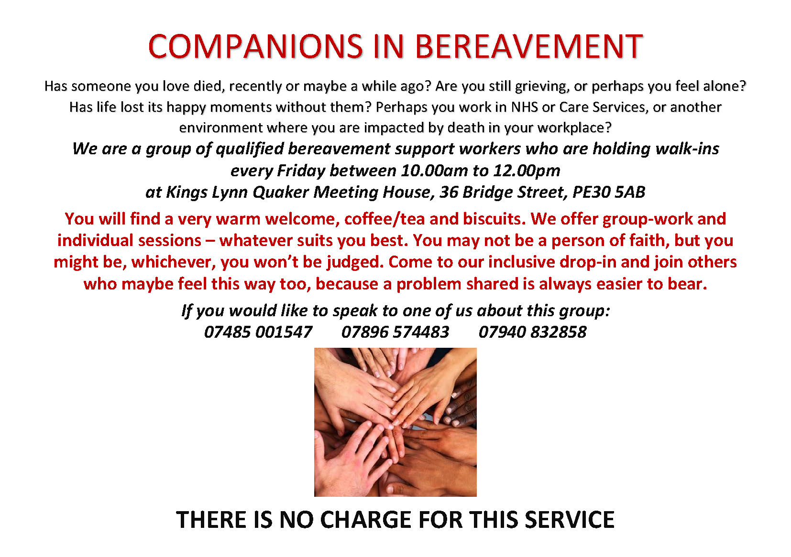

St John’s Church
07542 435094
stjohnschurchkl@outlook.com
https://www.sjkl.org.uk
Blackfriars Rd, PE30 1NT
Sunday Worship at 10.30
Welcome Inn Tuesday 11:30 – 13:00 Enjoy tea, coffee, and cake together.
Eagles youth group Friday 17:30 – 18:45

St Faith’s Church
Rev Kyla Sorenson & Rev Karlene Kerr
01553 774916 or 07841 632457
office@stfaithsgaywoodlep.org.uk
Gayton Rd, Gaywood, PE30 4DZ
Gaywood Community Hub
Youth Club
Community Meal
Saturday Coffee morning 10:00 -12:00
Church Rooms
Dementia Cafe

Our Lady of the Annunciation Catholic Church
Rev Peter Rollings
01553 772220
Parishpriest763@gmail.com
http://www.catholicparish-kingslynn.org.uk
London Road, King’s Lynn PE30 5HQ
Saturday Vigil Mass 18:00
Sunday Mass 11:30
Sunday Lithuanian Mass 13:00 (not weekly)
Sunday Vespers and Benediction 16:00
Monday Mass 12:00
Wednesday Mass 12:00
Friday Mass 12:00

