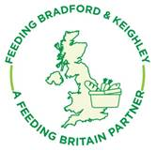
Feeding Bradford & Keighley
Wellsprings Together Office
The Trinity Centre, John Escritt Rd
Bingley BD16 2ST
Your name and organisation’s address

Dear (Ideally named manager, if not address to The manager, Supermarket name, branch)

We are writing a joint letter to you from Feeding Bradford & Keighley (our food poverty network) and add your name as a supermarket who kindly donates surplus food to our organisation.
Whilst we are extremely grateful for your generosity and kindness in supplying your local communities with surplus food, we are seeing growing numbers of out of date food being given to our groups. By law, we are not allowed to supply food that is past its ‘Use By’ date or is about to within a few hours. Whilst our ethos is ‘feeding people’ we also pride ourselves on reducing food waste by trying to educate our community groups and service users of better ways to utilise food and save it from landfill. With that said, we are asking you to support us in this drive to reduce waste and only provide food that we too are able to pass on legally. We want to stress that we are not rejecting food past its ‘best before’ because legally we are able to pass on this food. We have attached an information sheet that you could distribute to your staff, so that they too are aware of the differences between Use By and Best Before dates. We thank you for your time and look forward to receiving any questions you may have.

Yours sincerely
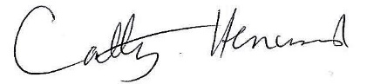
Cathy Henwood on behalf of Feeding Bradford & Keighley and
Your name etc with a signature

