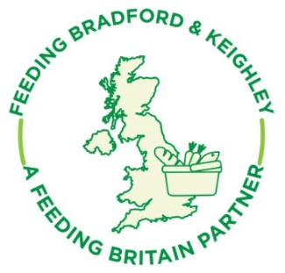
Notes- Feeding Bradford & Keighley Network Meeting
19th April 2021

- A large number of people from different organisations linked to food, as well as local authority, attended. Names can be provided on request.

- Update from the network
  - Foodbanks: Numbers still quite high. Practitioners webinar happening. Wednesday 28th April. https://www.eventbrite.co.uk/e/whats-next-for-our-foodbank-tickets-150502770839?ref=estw
  - Meal Provision: If anyone is starting or restarting provision, please could they let Cathy Henwood know, so we can update information.
  - Social supermarkets and low cost – Keighley are shortlisting applicants and interviewing next week. Will be working in the shop in the centre of Keighley. Looking for signposting organisations to partner with. Shop open by July hopefully.
  - Advice Worker in Food Settings: Will be funded to end of December, Feeding Britain to work with lottery on some more long term funding.

- Focus on school holiday funding Bradford Council: Sharon Sanders
95 HAF Projects in Easter. DfE funded, targeted at FSM recipients. £2m for Easter, summer and Christmas holidays. Focus is on the activity with food to accompany. Aligned to “live well” programme.
Wanting to learn from VSE for the past few years. Wanting to ensure as much as possible is face to face. Broad range of activities that also included “raising attainment” activities to help children catch up with missed education over the past year. Schools will be at the centre of identifying need. Some provision will be district-wide, some will be on a ward basis. Ward officers to help coordinate provision. Wanting to engage with wider families. Some sessions to be done with children and parents & carers. Recruiting 2 project managers.
Still deciding about how grants process will happen in summer holidays.
NT: asked if learning could be shared from last couple of holidays. SS: gaps will be identified.
JL: What about other holidays? SS looking to utilise other pots of funding to cover these.
JL: Please use expertise of Cathy Henwood, and the third sector brings something unique and value for money. SS: Cathy has been supportive. BDMC will manage the grants process. Schools will be at the centre as they know their communities.
BLF: Good to see connected approach. At Keighley Healthy Living we work with primary schools. They come to us for support.
K: How can the VCSE plan? What is the timeline for grant criteria etc? SS wanting to give adequate time and will keep updated.

- Mapping work of food provision by Bradford Council: Shanaz Yousaf
Food Insecurity has risen. Mapping tool to help you find gaps.
MC gave PowerPoint presentation to show how the tool can be used. PPT shared with attendees. Tool not currently live. If you want to book a 1:1 then please contact Shanaz and Mary who can help. Shanaz.Yousaf@bradford.gov.uk

- Date of next network meeting 12th July (venue tbc)

