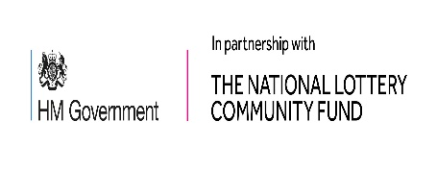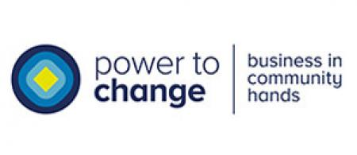
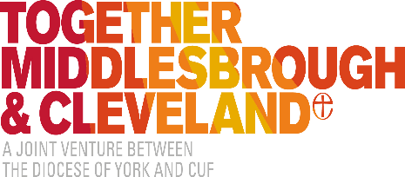
Project Officer
Fixed Term or Secondment opportunity, immediate start

PLEASE NOTE:

This post is funded by the National Lottery. We understand that this may be a concern for some applicants.

Together Middlesbrough & Cleveland’s Trustee Board is seeking applications for a Project Officer to take the lead on our food insecurity work. We are looking for someone to bring their personal knowledge, skills, and experience to co-ordinate and develop our work with organisations and residents across Middlesbrough and Redcar & Cleveland. The postholder will have the personal and professional experience to support the charity’s high-quality work in tackling poverty and supporting local communities to thrive and flourish. The successful candidate will work closely with the Chief Officer, to provide support in the current challenging landscape.
Due to grant conditions funding the post, the role is initially full time, Fixed Term, to the end of March 2021. However, there may be scope to extend the post, subject to funding. As we are looking for someone who can start immediately, we are happy to consider secondment opportunities from local organisations and/or job share options.
Hours: The post is full time (37.5hrs per week). Due to the temporary nature of the role, Secondments and Job Share options will be considered.
Salary: £26,813 pa.
Due to the current Government COVID 19 guidance on social distancing, interviews will take place online as soon as possible.
Further information including a Job Description and Person Specification; and the Application Form, is available at https://togethermc.org.uk/

To apply for this post, please email kathryn@togethermc.org to express an interest by 5 pm on Monday 30th November. We would then require a completed Application Form by 5pm on Friday 4th December

- TM&C Project Officer Job Description and Person Specification
- TM&C Project Officer Application Form

