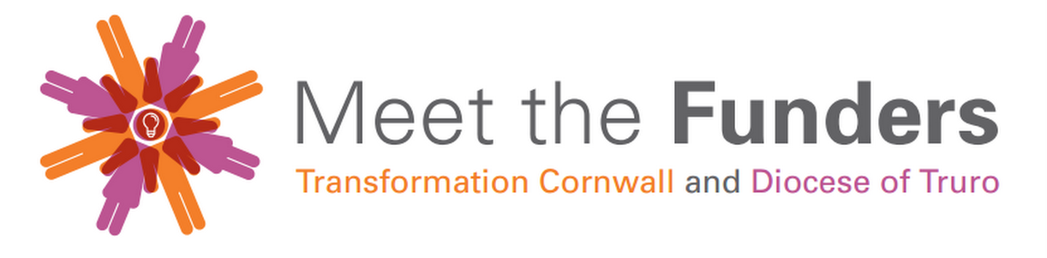
Questionnaire to improve a funding application

What were your general impressions (circle any of the words that apply and add your own)?

positive interesting professional friendly credible clear logical muddled confident well-argued reasonable boring tired cynical opportunistic too long too short sloppy needed too glossy type too small type too big pompous spelling mistakes apologetic depressing untidy vague complacent too informal full of emotional blackmail full of jargon inspiring has clear sections convincing too demanding grovelling committed easy to read patronising comprehensive
What would you say the project is trying to achieve?

Why is the project needed?

Is there anything about the project you do not understand?
Is there any way you think this application could be improved?

